How to Repeat a Value in WebFocus

WebFocus defaults to not repeating a like value in a column. However, it can easily be updated to repeat like values. For example, below is a report where the like items are not repeating.

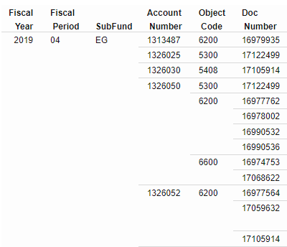

To have the like values repeat, on the “Format Tab” click on “Repeat Sort Value” button.

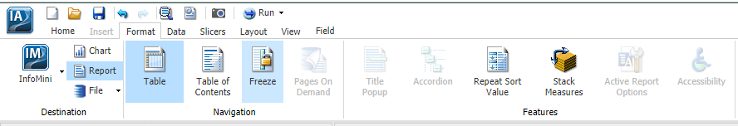

The below is how the report updates.

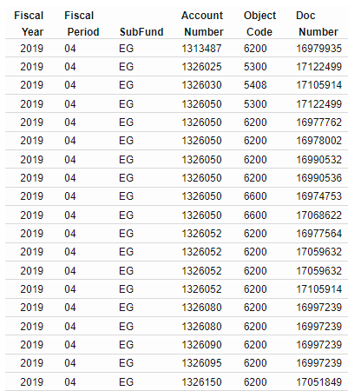

If the repeating values need to be removed, click on “Repeat Sort Value”.

