Accessing Data for WebFocus Reports

- When trying to create a new report within WebFocus and you are unable to see the Student, or Finance, or Research folders on the left, then you may not have access to this data within ODS.

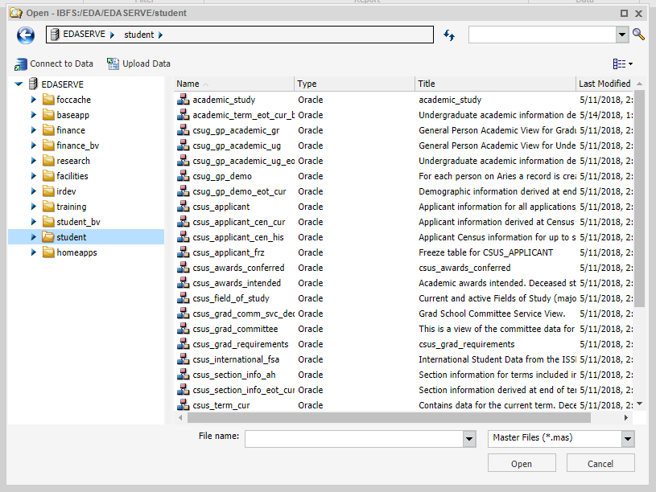

- Submit an ODS Data Access Request using https://aar.is.colostate.edu/. Under Application Systems click on Data Access Request. If you do not see the link for Data Access Request, click on Application Systems to expand the list of links.
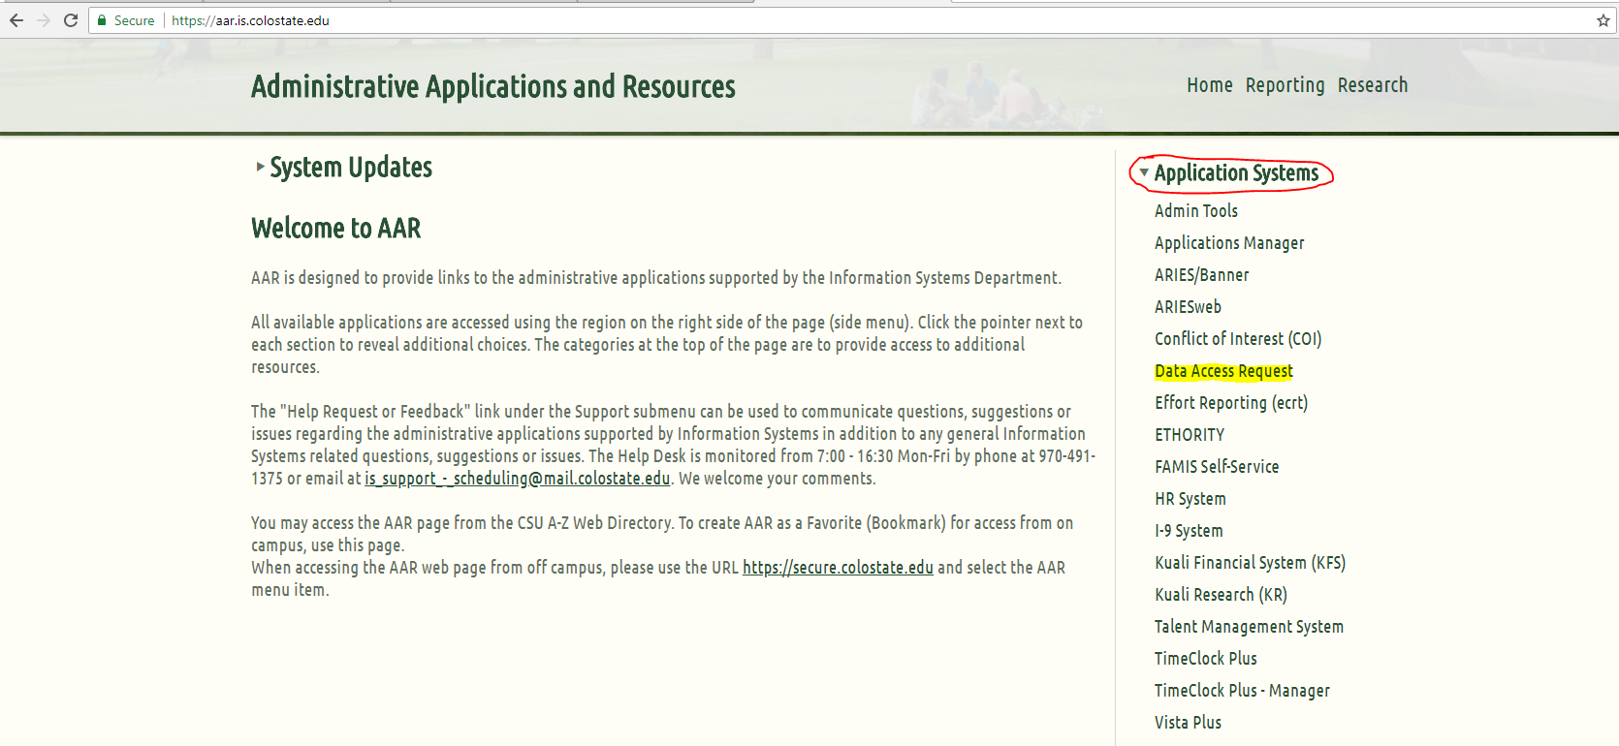

- Login using your EID and network password.
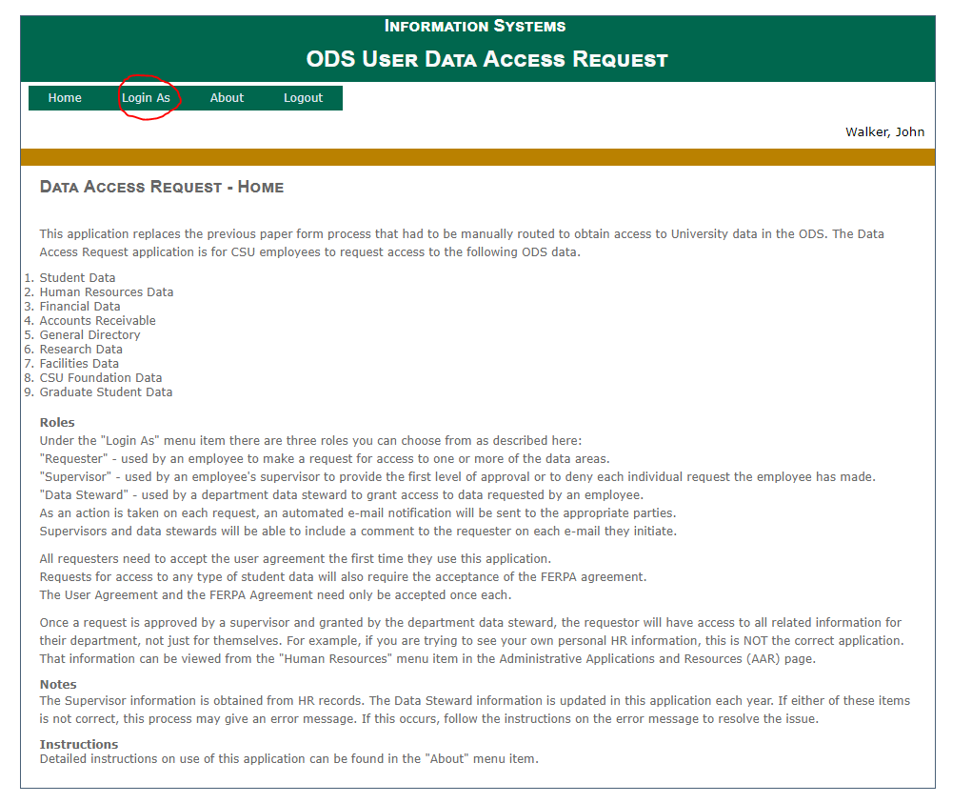
- Select Login As Requestor and you will see a screen of the data organized by functional areas of Student, HR, Finance, etc. This next screen shot shows that this person has access to Student Data, and can request data from Human Resources, Financial Data, Accounts Receivable, etc.
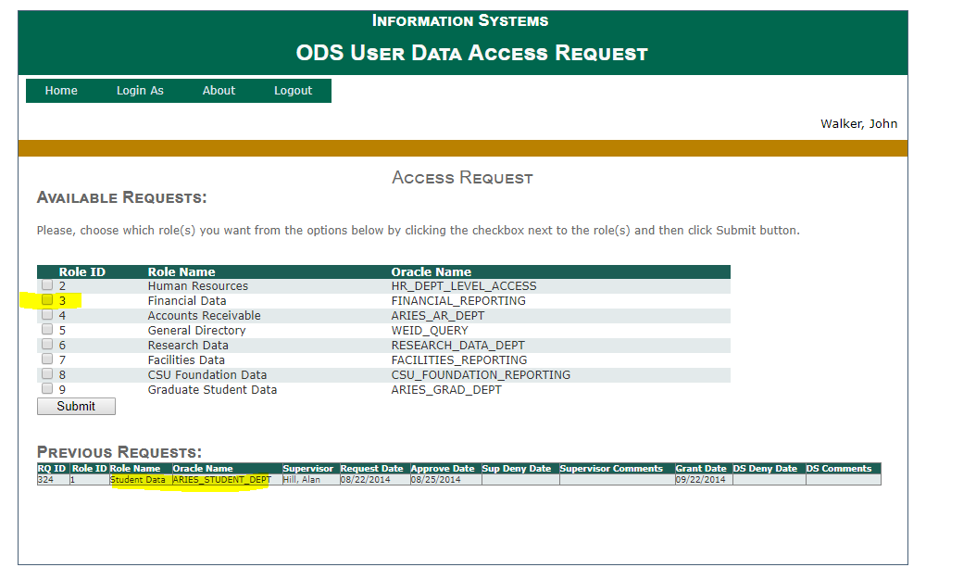
- Select the data that you will need access to. This will route to both your immediate supervisor and then to your Data Steward for approvals.

