How to ‘Save As’ a WebFocus report

- Edit a report in WebFocus by left mouse clicking on the selected report and choose ‘Edit’.

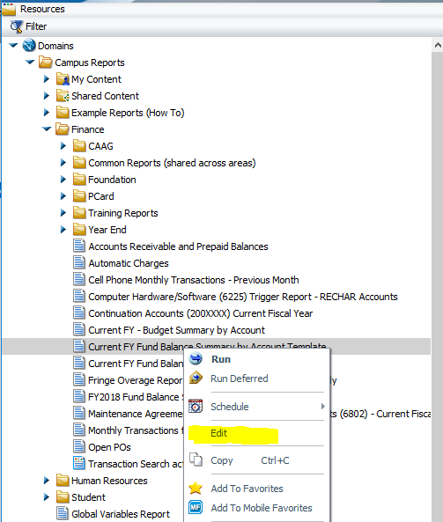

- After the report is in Edit mode, right mouse click on the ‘IA’ icon in the upper left corner of your web browser.
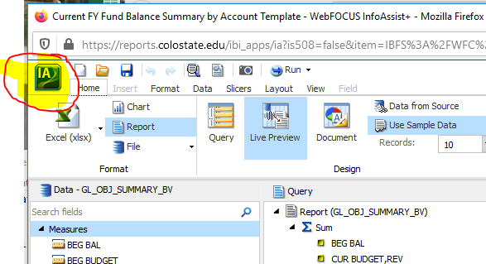

- Select ‘Save As’ from the drop down menu

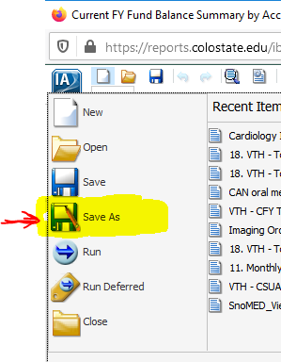

- Select which directory you would like to save your report in under ‘Domains’, rename your report in the ‘Title:’ field, and select the ‘Save’ button.

