Scheduling Reports in Web Focus
- Identify the report you want to send via email. Right click.
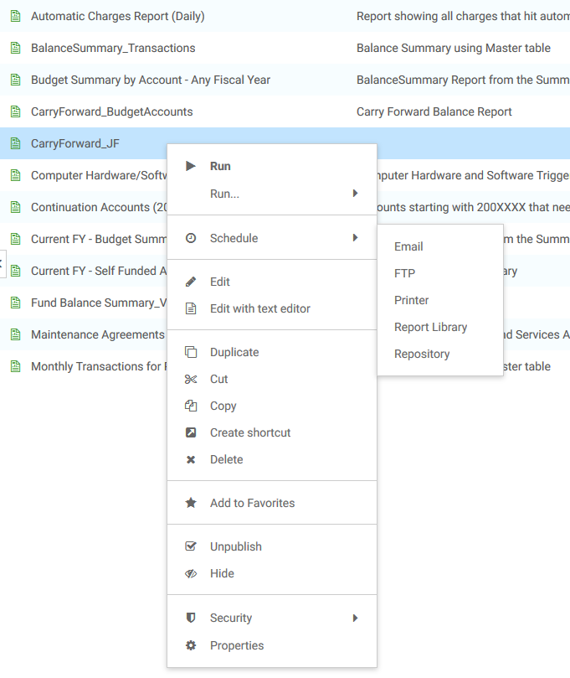
- Select Schedule.
- Select Email.
- The Scheduling Distribution screen opens.
  - Adjust the email addresses, subject line, and email information on this screen.
  - * NOTE: Do not change the From: or Reply Address: fields. This will cause the email server to block your message as SPAM.
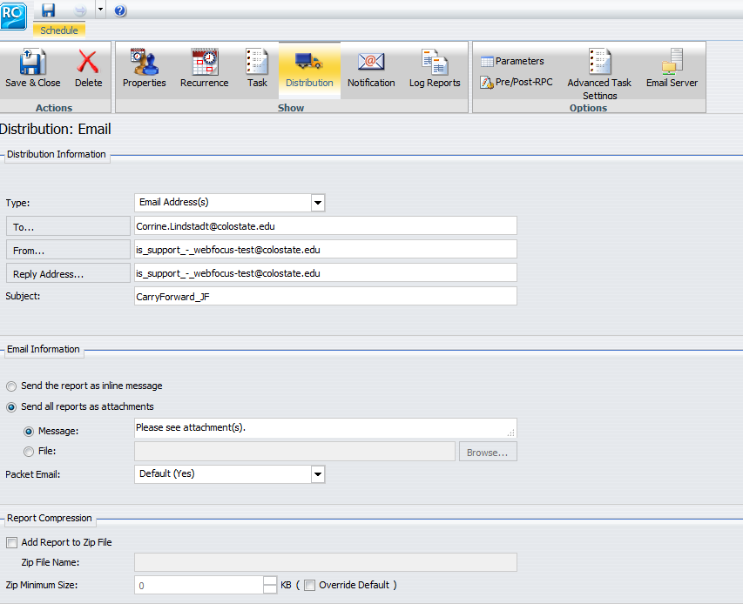
  - Click on the Recurrence tab to create a recurring email of the report.
    - Select the time, day, and frequency of the recurring email.
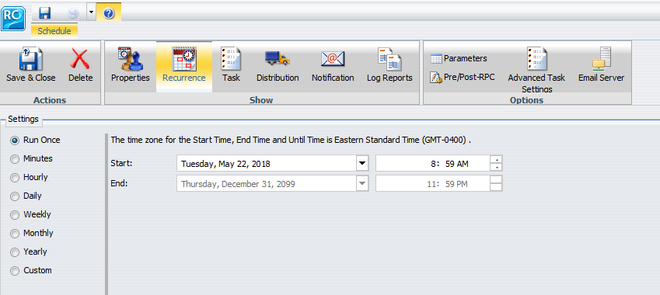
  - Click on the Notification tab. To receive an email notification when there is an error or when the email is sent, select “on error” or “always” from the drop down menu for Notification Type. Change the subject if desired.
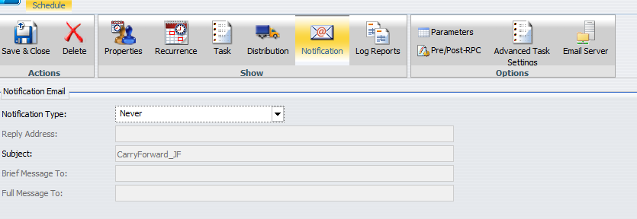

  - Click on the Parameters tab. The parameters listed under Name are the parameters built into the report you selected and change based on which report you select.
    - The report will not be able to be sent if any of the Values are blank.
      - To add or select a value, click on row that needs to be changed. Then click on the value box below or type a value directly into the box next to Value.
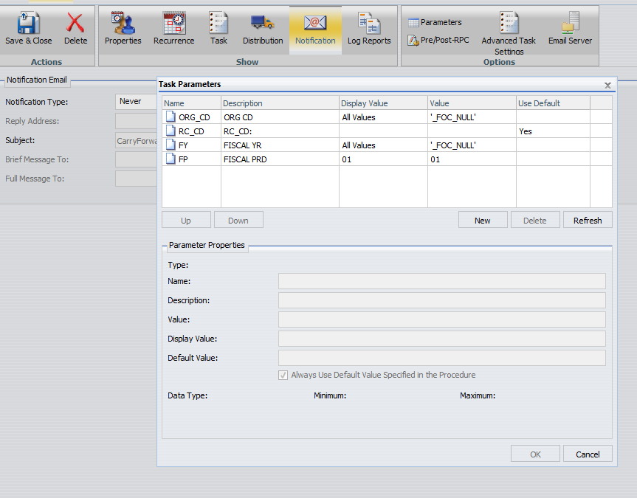
        - If you click on the Value box, you will get a pop-up with all of the value choices for that field based on the current data. Click OK after you select the values to include for that parameter.
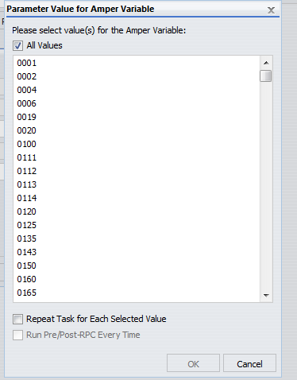
    - Click OK after you select the values to include for all parameters.
  - Click Save & Close.
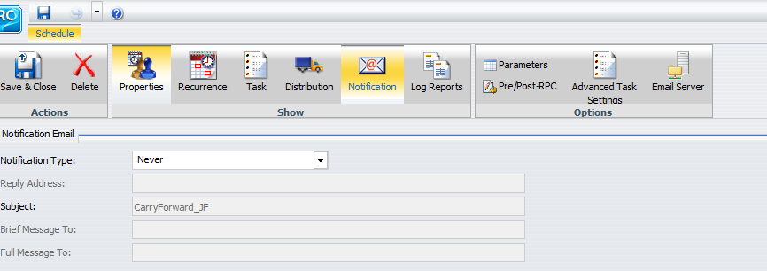
- The report will be sent via email based on the day and time selected in the Recurrence tab. If no changes were made to the Recurrence tab, the report will be sent right away.

- Below is an example email received through the scheduling proccess.
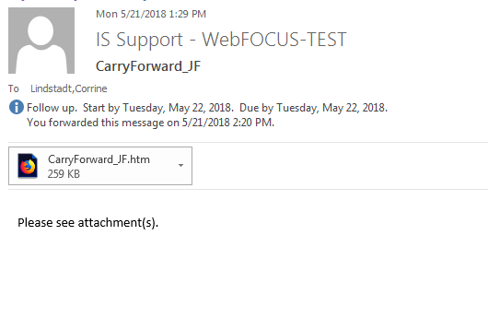
- Below is an example of the HTML attachment.
